Exploring the data with visualizations such as matplot for example the basketball data of players stats I was able to determine

* Fieldgoal attempts
* Field goals
* Games
* Minutes played
* Salary per point
* Points per minute

And so on also used a legend to make a chart to indicate players on the chart.

Made a visualization of minutes each player played.

We found out in popular players usually a decrease in time was caused by injury.

Kind of predictable but when you are looking at the graph to do something like average time before injury itll be important to know why there was a drastic dip in a players playing time.

Stats for internet

#------------ visualization what we need

qplot(data= stats, x=Internet.users, y=Birth.rate)

qplot(data= stats, x=Internet.users, y=Birth.rate,

colour=I("red"), size=I(4))

#different income groups to different colors

qplot(data= stats, x=Internet.users, y=Birth.rate,

colour=Income.Group, size=I(5))

birthrate low but they have internet…..but the correlation doesn’t go to causations

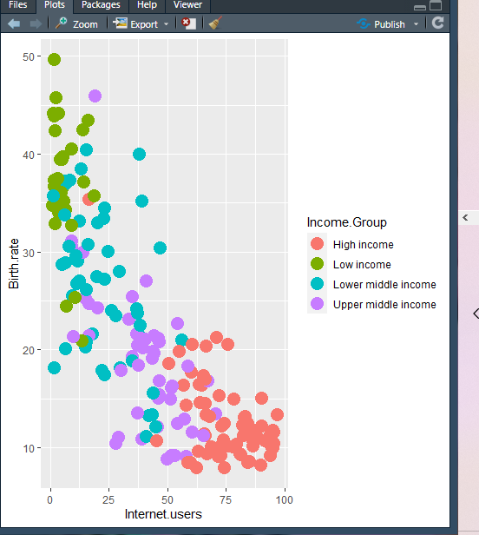



7 layers

